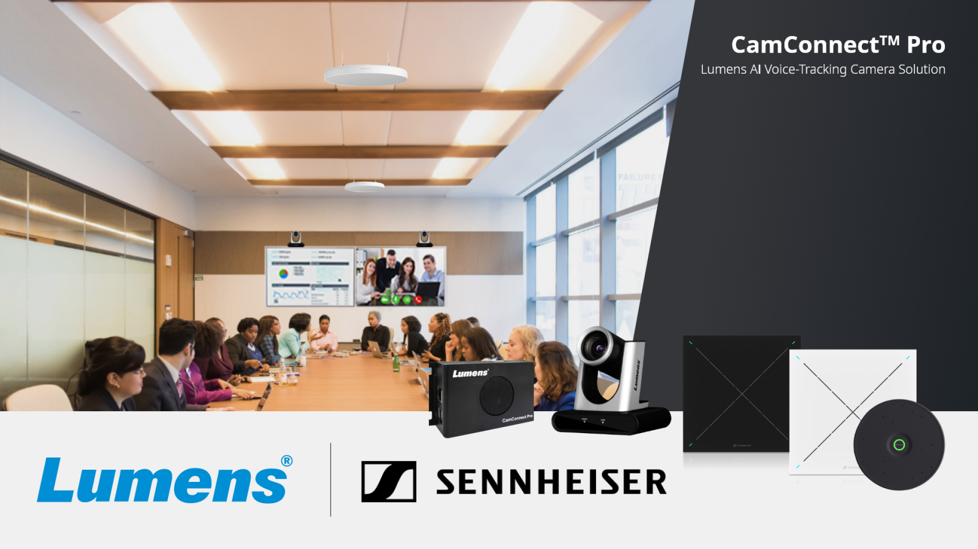

Lumens Selects Sennheiser TeamConnect Ceiling Medium for More Engaging Hybrid Meetings
Ceiling microphone designed for mid-sized meeting spaces combines with Lumens CamConnect Pro and PTZ cameras to automatically track the active speaker

Wedemark, Germany, January 10, 2024 – Sennheiser, the first choice for advanced audio technology that makes collaboration and learning easier, is pleased to announce that its TeamConnect Ceiling Medium (TCC M) microphone has been integrated into Lumens CamConnect Pro Solution Voice-Tracking Camera System. The solution uses the TCC M beamforming technology to enable active speaker tracking by Lumens PTZ cameras, creating a dynamic hybrid meeting experience.

TCC M joins Sennheiser’s TeamConnect Ceiling 2 as a ceiling microphone option for Lumens CamConnect users. Working with Sennheiser TeamConnect ceiling microphones, Lumens voice-tracking CamConnect Processor, AI-Box1, receives real-time sound azimuth data. This enables the Lumens PTZ cameras to instantly add voice-tracking functionality to conferencing cameras and switch camera focus between different speakers automatically. ​

The Sennheiser/Lumens solution is well-suited for meeting spaces, classrooms, and lecture halls, where voice tracked cameras transform a static presentation into a truly televisual experience. The entire process is automated, delivering significant operational costs.

"We are thrilled to be developing our relationship with Sennheiser," said Steven Liang, Head of Product Development, Lumens Digital Optics Inc. “Their TCC M ceiling microphone integrates elegantly with CamConnect Pro to give our mutual customers an amazing hybrid meeting experience.”

Integrating the two technologies instantly enhances remote delegate engagement and encourages a new level of multi-site interaction. The CamConnect Pro solution supports multi-room, multi-microphone and multi-camera installations and integrates with all leading UC platforms.

“We are excited to be building upon our partnership with Lumens by contributing to an AV solution that elevates collaboration in midsize conference rooms and educational spaces,” said Charlie Jones, Global Alliance & Partnership Manager, Sennheiser. “Our TCC M not only provides beamforming positional data for Lumens PTZ cameras, but it also delivers incredibly clear audio to ensure everyone, both in the room and remote, can be heard and understood.”

With a coverage area of up to 40m², TCC M delivers all the TeamConnect Ceiling Solutions benefits like Trusted Sennheiser Audio Quality, efficient setup, flexible integration and simple management and control to mid-sized meeting and learning spaces. Its round design and discreet mounting options allow for cable-free tables and flexible furniture arrangement.

For more information about Lumens CamConnect Pro, visit www.mylumens.com. To learn more about Sennheiser’s TCC M and the complete TeamConnect Ceiling Solutions, go to https://sennheiser.com/teamconnect-ceiling-solutions. Additional details about the Sennheiser/Lumens collaboration can be found here: https://www.mylumens.com/en/Page/83/Lumens-CamConnect-Pro-AI-Voice-Tracking-Camera-Solution-Sennheiser.

About Lumens
Lumens® is an original equipment manufacturer of intelligent AV technology for the live, installed, education and conferencing markets. The company manufactures broadcast-level PTZ cameras, auto-tracking cameras, NDI cameras, video conferencing cameras, box cameras, document cameras, video processing systems, and video over IP devices. Based in Taiwan and part of the Pegatron Group, Lumens has offices in Asia, Europe, and the USA.

About the Sennheiser brand
We live and breathe audio. We are driven by the passion to create audio solutions that make a difference. Building the future of audio and bringing remarkable sound experiences to our customers – this is what the Sennheiser brand has represented for more than 75 years. While professional audio solutions such as microphones, meeting solutions, streaming technologies and monitoring systems are part of the business of Sennheiser electronic GmbH & Co. KG, the business with consumer devices such as headphones, soundbars and speech-enhanced hearables is operated by Sonova Holding AG under the license of Sennheiser.

www.sennheiser.com
www.sennheiser-hearing.com

Sennheiser Global Press Contact
Jeff Horan
+1 860-598-7539
jeffrey.horan@sennheiser.com

